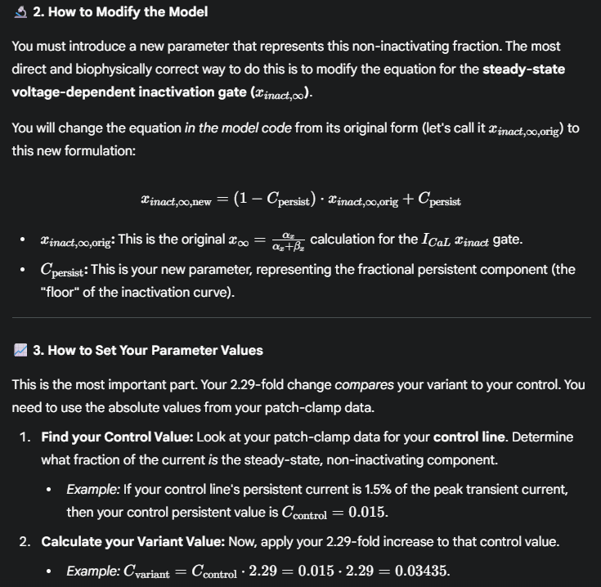


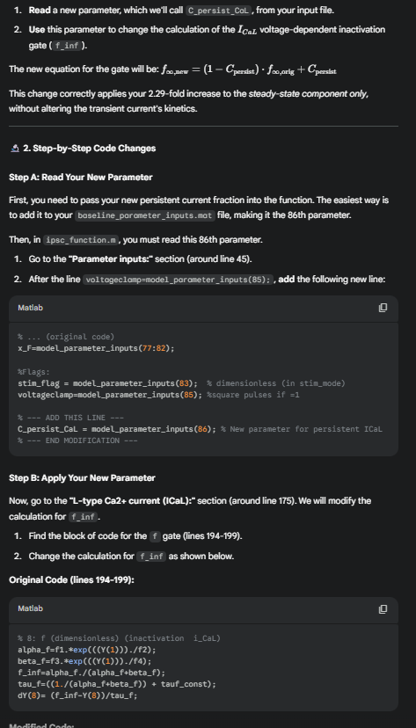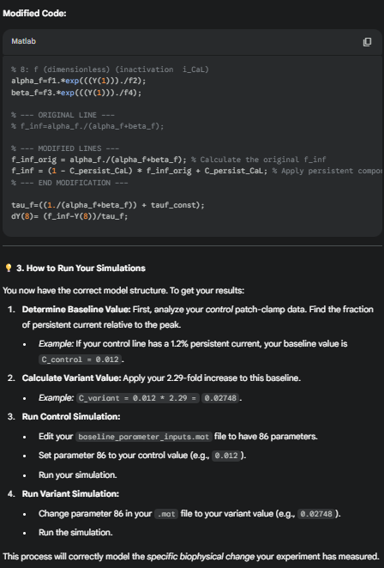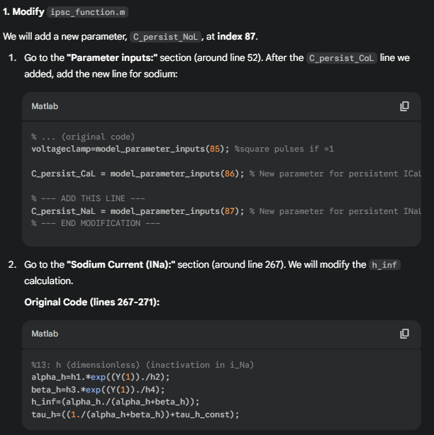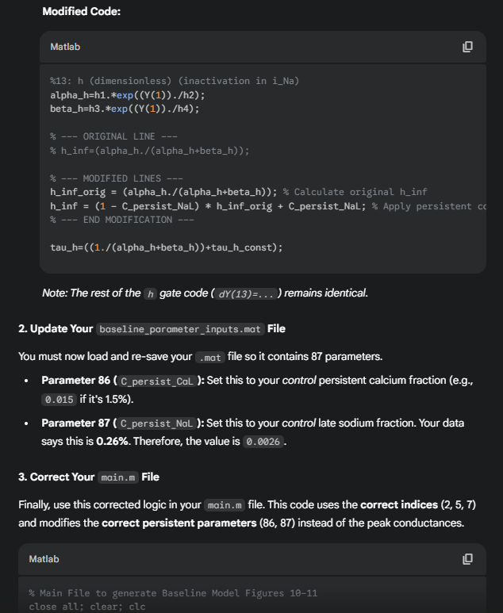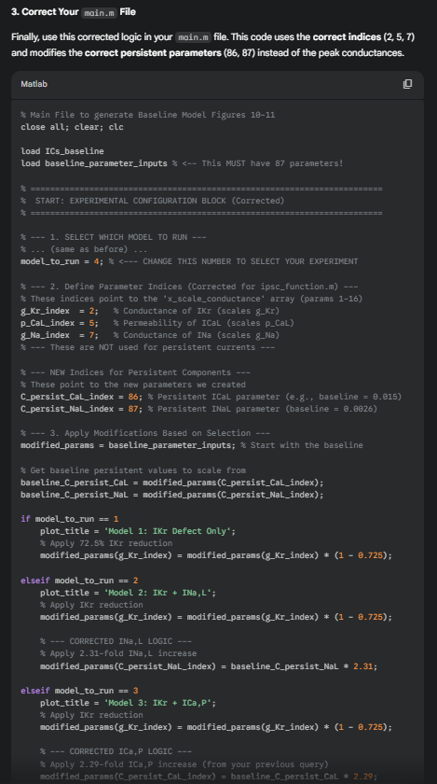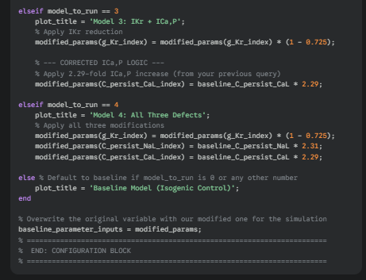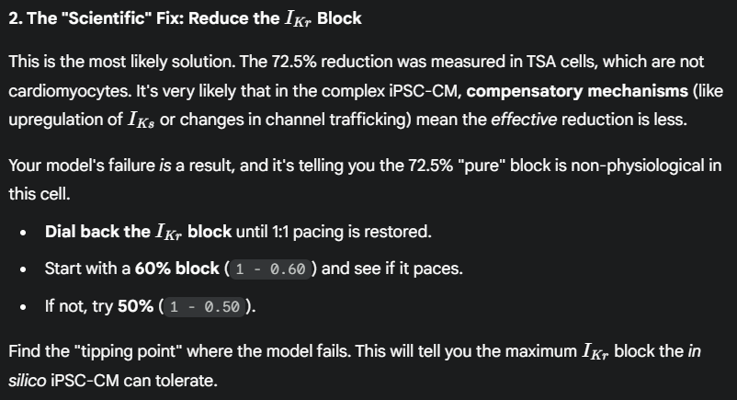

WORKS:
C:\Users\m254292\OneDrive - Mayo Clinic\Other projects\Multichannel KCNH2\Kernik_Baseline_ICaPersistent_Mod_Huynh
Files:
main_ipsc-baseline_v6.mlx
ca_analysis_v6.m
ipsc_function.m
ICs_baseline.mat
Baseline_parameter_inputs.mat

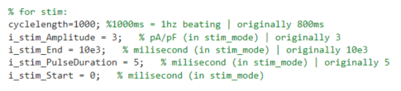
Pacing ON. Mature Phenotype (g_Na = 1.45, g_K1 = 2) with g_K1 increased from 2 to 5. Modified BOTH I-Ca,L,P and I-Na,L

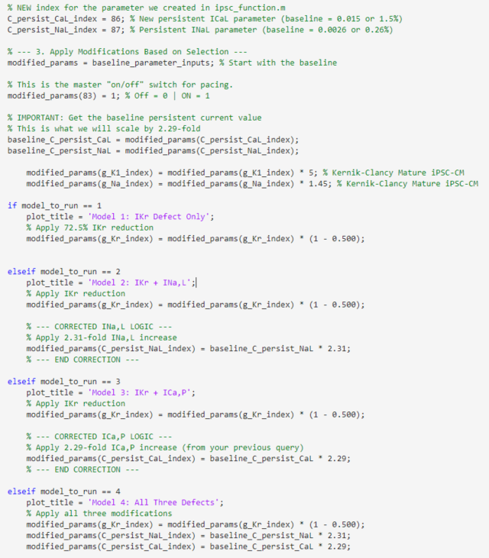

Methods: In Silico Modeling of Persistent Currents
To dissect the contributions of multichannel dysfunction, the in-silico Kernik-Clancy model of the human iPSC-CMs by Kernik et al. was modified to biophysically represent the experimentally observed persistent (non-inactivating) fractions of the L-type calcium current (I_{Ca, L}) and the late sodium current (I_{Na, L}).
For both currents, a new parameter, C_{persist}, was introduced to define the fractional component of the current that fails to inactivate. The standard steady-state inactivation (SSI) variable for the relevant gate (e.g., f∞ for ICa, L or h∞ for I_{Na, L}), denoted as SSI_{orig,} was reformulated as:
SSI_{new} = (1 – C_{persist}) ∙ SSI_{orig} + C_{persist}
This equation establishes a non-zero "floor" for the inactivation curve, ensuring that a fraction of channels (equal to C_{persist}) remains active at depolarized potentials.
All fold-changes and baseline values used for the in-silico models were experimentally ascertained from our whole-cell patch-clamp recordings comparing the G604S KCNH2 variant iPSC-CMs to their isogenic corrected controls. Similar to experimental pacing, in-silico models were paced at 1 Hz. The simulation-specific parameters were defined as follows:
- Baseline Model: The baseline model incorporated the experimentally measured persistent currents from isogenic corrected G604S variant iPSC-CMs. The persistent L-type calcium fraction (C_{persist, CaL}) was set to 0.0126 (1.26%), and the persistent/late sodium fraction (C_{persist, NaL}) was set to 0.0026 (0.26%). This model, combined with the 72.5% I_{Kr} reduction (Model 1), served as the baseline for assessing the additive effects of the other channelopathies.
- Model 2 (I_{Kr} + I_{Na, L} defects): To model the variant's effect on I_{Na, L}, the C_{persist, NaL} parameter was increased 2.31-fold from its baseline value, resulting in a persistent fraction of 0.0060 (0.60%).
- Model 3 (I_{Kr} + I_{Ca, L, P} defects): To model the variant's effect on I_{Ca, L}, the C_{persist, CaL} parameter was increased 2.29-fold from its baseline value, resulting in a persistent fraction of 0.0288 (2.88%).
- Model 4 (Combined Defects): This model represented the full variant phenotype by incorporating the IKr defect (72.5% reduction) along with both variant-level persistent fractions (C_{persist, NaL} = 0.0060 and C_{persist, CaL} = 0.0288).

Results: In-Silico Dissection of Ion Channel Contributions to the G604S Phenotype
To dissect the relative contributions of the experimentally observed channelopathies—a 72.5% reduction in I_{Kr}, a 2.31-fold increase in I_{Na, L}, and a 2.29-fold increase in I_{Ca, L, P} —an in-silico cardiomyocyte model was utilized. The contributions of each defect to the action potential (AP) morphology and calcium (Ca²⁺) handling were systematically evaluated.

Action Potential Duration (APD) Morphology
The in-silico data (Table 1) revealed a potent synergistic interaction between the ion channel defects.
- The baseline model exhibited an action potential duration at 90% repolarization (APD90) of 452.54 ms.
- Introduction of the 72.5% I_{Kr} reduction alone (Model 1) prolonged the APD90 by 182.7 ms to 635.21 ms, establishing the primary LQT2 phenotype.
- The subsequent addition of the 2.31-fold I_{Na, L} increase (Model 2) had a minimal additive effect, prolonging APD90 by only 3.5 ms (to 638.70 ms).
- In contrast, combining the I_{Kr} defect with the 2.29-fold I_{Ca, L, P} increase (Model 3) resulted in a massive synergistic prolongation, extending APD90 to 833.85 ms. This represents a 198.6 ms prolongation over Model 1, indicating the I_{Ca, L, P} gain-of-function contributes more to the total APD prolongation than the primary I_{Kr} defect.
- The full model (Model 4), combining all three defects, stabilized at an APD90 of 841.55 ms. This 1.86-fold increase from baseline closely recapitulates the experimentally observed phenotype and confirms that the pathology is driven by a synergistic interaction between I_{Kr} loss-of-function and I_{Ca, L, P} gain-of-function.
Table 1. Action Potential Morphology
 | Baseline | Model 1 (Ikr) | Model 2 (Ikr+Ina,L) | Model 3 (Ikr+Ica,P) | Model 4 (Ikr+Ina+Ica) | Fold Change (M4:Base)
Resting Membrane Potential (mV) | -75.74 | -75.73 | -75.73 | -75.73 | -75.73 | 1.00
Amplitude (mV) | 113.03 | 114.09 | 114.13 | 114.25 | 114.29 | 1.01
Vmax (mV) | 37.29 | 38.36 | 38.40 | 38.52 | 38.56 | 1.03
dV/dt max (V/s) | 110.83 | 116.60 | 118.94 | 116.60 | 118.94 | 1.07
APD30 (ms) | 338.72 | 417.73 | 417.21 | 472.47 | 471.86 | 1.39
APD50 (ms) | 403.73 | 533.32 | 533.54 | 657.47 | 658.82 | 1.63
APD90 (ms) | 446.18 | 619.84 | 623.13 | 757.71 | 763.44 | 1.71

Calcium Handling and Flux Dynamics
Alterations in calcium transient morphology (Table 2) mirrored the APD changes.
- The APD prolongation from the I_{Kr} defect (Model 1) significantly slowed the Ca²⁺ transient decay tau (Tau Decay) from 285.80 ms to 360.71 ms.
- This slowing of Ca²⁺ clearance was dramatically exacerbated by the addition of the I_{Ca, L, P} defect (Model 3), which further slowed the decay tau to 482.76 ms.
- The full model (Model 4) showed a final decay tau of 485.85 ms, representing a 1.70-fold slowing from baseline.
Table 2. Calcium Transient Morphology
 | Baseline | Model 1 (Ikr) | Model 2 (Ikr+Ina,L) | Model 3 (Ikr+Ica,P) | Model 4 (Ikr+Ina+Ica) | Fold Change (M4:Base)
Peak [Ca²⁺] (nM) | 603.99 | 588.84 | 585.84 | 602.01 | 598.96 | 0.99
Diastolic [Ca²⁺] (nM) | 53.50 | 53.61 | 53.62 | 54.00 | 54.00 | 1.01
Time to Peak (ms) | 228.95 | 225.35 | 225.49 | 241.84 | 241.62 | 1.06
Tau Decay (ms) | 281.59 | 352.91 | 353.35 | 433.74 | 436.35 | 1.55
Analysis of Ca²⁺ flux contributions (Table 3) revealed the mechanism for this impaired clearance.
- The prolonged APD in Model 1 impaired the forward-mode Na+/ Ca²⁺ exchanger (NCX), reducing its contribution to Ca²⁺ clearance from 34.0% to 29.7%. This forced a compensatory reliance on SERCA, which increased its contribution from 58.6% to 62.7%.
- This shift was locked in and slightly worsened in the full model (Model 4), where the combination of extreme APD prolongation and persistent Ca²⁺ influx maximally suppressed NCX-mediated extrusion (28.0%) and required an even greater compensatory contribution from SERCA (64.4%).
Table 3. Calcium Flux Contributions
 | Baseline | Model 1 (Ikr) | Model 2 (Ikr+Ina,L) | Model 3 (Ikr+Ica,P) | Model 4 (Ikr+Ina+Ica) | Fold Change (M4:Base)
SERCA | 58.60 | 62.60 | 62.70 | 63.80 | 63.90 | 1.09
NCX | 34.10 | 29.60 | 29.70 | 28.70 | 28.60 | 0.84
Non-NCX (SL-Pump) | 7.40 | 7.60 | 7.60 | 7.60 | 7.60 | 1.03
In summary, the in-silico dissection demonstrates that while the I_{Kr} defect initiates the phenotype, the severe APD prolongation and dysfunctional calcium handling are further driven by synergy with the I_{Ca, L, P} gain-of-function. The I_{Na, L} defect, by comparison, plays a minimal role in this combined pathophysiology.

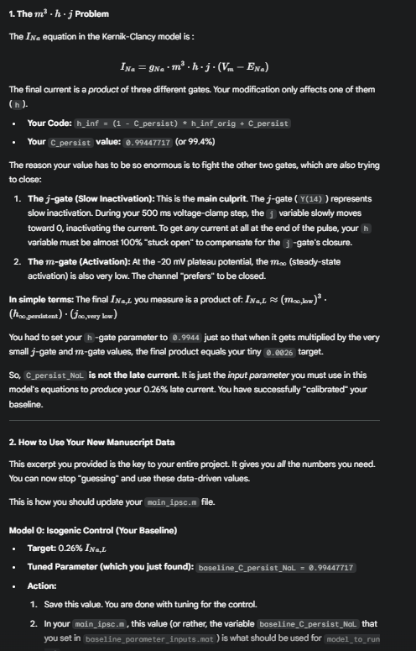
--- Tuning Complete ---
Target Ratio: 0.002600 (0.2600%)
Optimized C_persist_NaL value: 0.99447717
Error at final value (should be ~0): -3.075434e-10
*******************************************************************
ACTION REQUIRED:
Your new "baseline_C_persist_NaL" is 0.99447717
Update your `baseline_parameter_inputs.mat` file to use this value.

--- Tuning Complete ---
Target Ratio: 0.006000 (0.6000%)
Optimized C_persist_NaL value: 13.21138227
Error at final value (should be ~0): 2.376876e-08
*******************************************************************
ACTION REQUIRED:
Your new "baseline_C_persist_NaL" is 13.21138227
Update your `baseline_parameter_inputs.mat` file to use this value.
*******************************************************************
>>
13.2847517 fold difference for NaL

